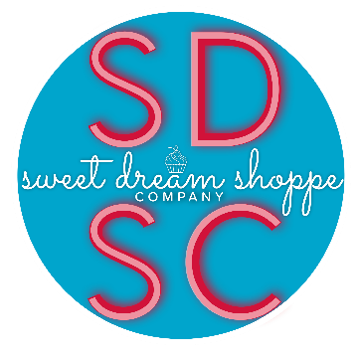
Flavor List
Almond Amaretto Any Candy Bar Flavor
Apple Crisp Apple Pie Bahama Mama
Banana Banana Nut Banana Pudding
Banana Split Blueberry Brownie Bit
Butterscotch Caramel Apple Pie Caramel Popcorn
Carrot Chocolate Chocolate Chip
Chocolate Covered Strawberry Cinnamon Roll Coconut
Coconut Rum Cake Cookie Dough Cookies and Cream
Cotton Candy French Vanilla Funfetti
German Chocolate Guava Lemon
Maple Bacon Maple Buttered Pecan Marble
Marble Mint Chocolate Mint Chocolate Chip
Neapolitan Passion Fruit PB & J
Peach Cobbler Peach Sweet Tea Peaches and Cream
Peanut Butter Brownie Pecan Pie Peppermint
Pina Colada Pineapple Pineapple Upside Down Cake
Pink Champagne Pistachio Pound Cake
Pumpkin Rainbow Sherbet Red Velvet
Rocky Road Shirley Temple S'mores
Snickerdoodle Spice Strawberries and Cream
Strawberry Strawberry Cheesecake Strawberry Daquiri
Strawberry Lemonade Strawberry Nutella Tequila Sunrise
Tiramisu Velvet Wedding Cake
White Chocolate Cherry Yellow Butter
Fillings
Almond Cream Cheese Buttercream Banana Bavarian Cream
Bavarian Cream with Fresh Fruit Caramel Dulce De Leche Chocolate Buttercream
Coconut Coffee Milk Buttercream Cookies and Cream
Cream Cheese Fresh Fruit Fudge
Funfetti Buttercream Ganache: white chocolate, chocolate Guava
Hazelnut Nutella Lemon Curd Mousse
Passion Fruit Peanut Butter Buttercream Raspberry Buttercream
Raspberry Preserves Strawberry Buttercream Strawberry Preserves/Glaze
Vanilla Cream Cheese Buttercream
Icings
Almond Cream Cheese Buttercream Caramel Dulce De Leche Chocolate Buttercream
Coffee Milk Buttercream Cookies and Cream Fondant
Funfetti Buttercream Ganache Hazelnut Nutella Buttercream
Peanut Butter Buttercream Raspberry Buttercream Strawberry Buttercream
Swiss Meringue Buttercream Vanilla Cream Cheese Buttercream Whipped Cream

*This is a generous list. Other flavors may be added or taken away. If you have any flavor suggestions, just email us! We would love to hear your ideas!!*

